

Hughes Primary School
Inclusion Policy

Hughes Primary School Inclusion Policy

Inclusion is a human right (Declaration on the Rights of Disabled Persons 1975)
Rationale
At Hughes Primary School, we are committed to supporting every student’s growth and success. Our inclusive approach underpins all aspects of the International Baccalaureate Primary Years Programme including the attributes of the IB Learner Profile as well as our established Positive Education model. We embrace the social model of disability, as outlined in the UN Convention on the Rights of Persons with Disabilities and the Disability Discrimination Act 1992 and foster a welcoming community. We celebrate each child’s strengths and interests and uphold our core values—Be Kind and Try Your Best—in all our interactions. We believe that inclusion is a continual process focused on removing barriers and ensuring every student can access and engage fully in learning (Learning diversity and inclusion in IB programmes).

We are committed to fostering a welcoming, safe, and equitable school environment where all students—regardless of ability, cultural background, language, gender, socioeconomic status, or any other difference—are respected, included, and supported to reach their full potential. At Hughes:
- We embrace and celebrate the different backgrounds, identities, talents, and perspectives each student brings.
- We proactively identify and reduce physical, academic, social, and emotional barriers to learning and participation for every student.
- We provide differentiated curriculum, reasonable adjustments, and flexible teaching strategies so all students, including those with disabilities and learning differences, can access core learning.
- We create opportunities for students to build friendships, develop social skills, and participate in all aspects of school life. We support the emotional wellbeing of every child and encourage positive peer relationships.
- We respect and integrate students’ cultural identities, languages, and family backgrounds into our school practices and curriculum.
- All students are encouraged to participate meaningfully while learning, playing, and interacting together, rather than being separated or excluded from their peers.
- We work closely with families, allied health professionals, and the community to support each student’s unique needs.
- Students are empowered to express their thoughts, needs, and preferences, knowing their voices are valued and heard.
- Staff regularly review and improve inclusive practices, policies, and school culture to respond to the evolving needs of our diverse student community.

Inclusion is not just a practice—it is a guiding principle that shapes every aspect of our primary school. Our goal is to ensure every child belongs, is respected, and can thrive.

As an ACT Education Directorate school we comply with the Disability Discrimination Act 1992 and the Disability Standards for Education 2005. ACT, ensuring we offer differentiated programs and make reasonable adjustments so all students can access and participate in education on the same basis, with comparable choices and opportunities, as other students.

As an inclusive schooling system, we aim to ensure that students with disability access and participate in learning and extracurricular activities to the greatest extent they can and on an equal basis with their peers.
This means:
• students with disability can access, contribute and participate to the maximum extent in all aspects of the life of their school.
• all school environments are welcoming and safe, instil high expectations and aspirations, and are free from violence, abuse and neglect.
• school supports are effective and meet the diversity of student needs.
• students with disability achieve individual educational goals in and beyond school.
• students with disability develop social skills and maximise their capacity to make choices.
• the attitudes and behaviour of students, teachers, principals and educational authorities show they embrace diversity and the inclusion of students and teachers with disability.

Royal Commission into Violence, Abuse, Neglect and Exploitation of People with Disability: Final Report, Volume 7, pg. 108 (Word version), pg. 88 (PDF version)

What you will see at Hughes Primary School
At Hughes Primary School, we have developed shared beliefs and practices alongside well-established procedures that are designed to ensure every member of our community feels welcomed, understood, included, and safe. We begin with the presumption that all children can learn and participate in education on the same basis as their peers, and we actively consider the views of both children and their families when designing learning options tailored to individual needs. This commitment is supported by our Individual Learning Plan (ILP) processes, which are holistic in nature; while academic outcomes are important, we also recognise the broader learning necessary to prepare children to value diversity and become positive, connected, and inclusive members of the community.

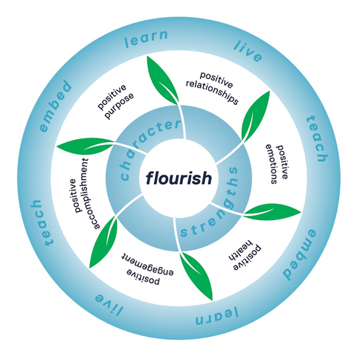
Our Units of Inquiry explicitly embed the attributes of the Learner Profile and principles of Positive Education, ensuring that students develop essential skills in emotional intelligence, resilience, gratitude, and wellbeing as part of their everyday learning. Through these inquiry-based units, students engage in explicit learning experiences that foster self-awareness, positive relationships, and a growth mindset, empowering them to thrive both academically and personally.

Fostering strong, trusting relationships between educators, children, and families is central to our approach, and these relationships are further strengthened by support from wider networks. We ensure that resources are allocated effectively and appropriately to make the necessary adjustments for students, and we support both established and innovative differentiated practices to facilitate learning and growth for all.

We acknowledge that diversity is highly individual and may require adjustments to address impacts in areas such as movement, understanding, communication, learning, thinking, seeing, hearing, sensory processing, physical appearance, and physical or mental health. Adjustments may be required temporarily or on an ongoing basis, and since the impact of disability may change over time, these supports need to be reviewed regularly. This approach applies to all children and young people who require additional supports and adjustments to access learning. Although the focus of this strategy is inclusion for children with disability, we recognise that many children with disability may also be culturally or linguistically diverse, identify as LGBTQI+, or be Aboriginal and Torres Strait Islander. All forms of diversity are valued and celebrated by Hughes Primary School and will be considered when meeting the needs of all learners.

Our staff receive ongoing support, training, and recognition as they plan and implement strategies to meet student needs. We are committed to continuous improvement, regularly reviewing and modifying student plans and school procedures to enhance outcomes over time. We also support children to be prepared, ready, and confident to transition to new and different stages of learning and life. Finally, we maintain a robust and clear plan for supporting students with disability, working collaboratively with our Student Resource Team, including the school psychologist, to provide comprehensive assistance.
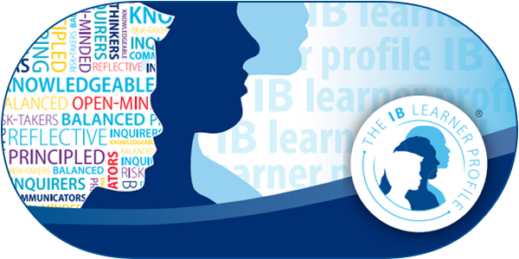

In Australia, discrimination laws are governed by both federal and state legislation. Key federal laws include:
• Commonwealth Disability Discrimination Act 1992 and Disability Standards for Education
2005: Prohibiting discrimination based on disability.
• Racial Discrimination Act 1975: Addressing discrimination based on race, colour, descent, or
national or ethnic origin.
• Sex Discrimination Act 1984: Protecting against discrimination based on sex, marital status,
pregnancy, or potential pregnancy.

