

Hughes Primary School
Learning for Life
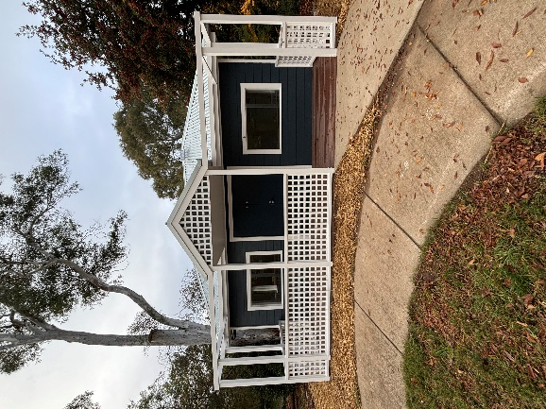
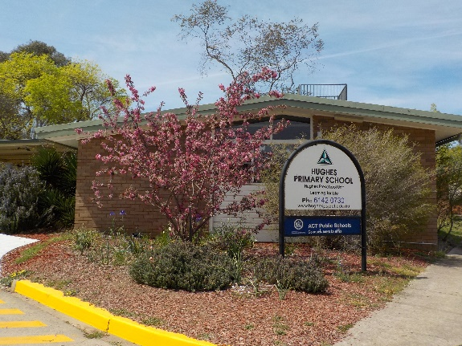
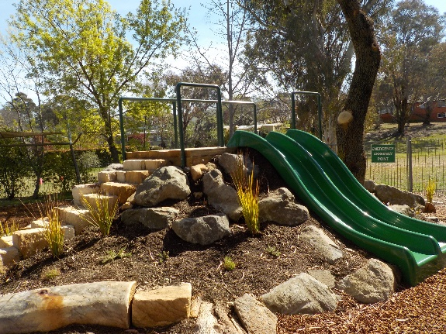

Preschool Family Handbook 2025

hlan'wa sahla 歡迎 欢迎 Bienvenue Willkommen Καλώς ορίσατε Benvenuto ようこそ 환영합니다
歡迎歡迎 Haere maBienvenid Dobrodošli Herzlich willkommen Swaagat Selamat datang Benvenuti Benvenute أهلا وسهلا Witajcie добро пожаловать Dobrodošli Bienvenidos HOAN NGHINH

Table of Contents
Table of Contents 2
Welcome from Principal 4
Contact Details 5
Hours of Operation 5
Term Dates 5
Hughes Preschool Philosophy Statement 6
Curriculum 8
National Quality Framework 9
A – Z of Information 10
Arriving and Departing - Delivery and Collection of Children 10
Belongings 11
Birthdays 11
Celebrations 11
Changes to Details 11
Child Protection Practices 11
Clothing 11
Concerns, Complaints or Commendations 12
Communication avenues with staff 12
Contribution to decision making 13
Pockets 14
Dogs 14
Drinks 14
Emergency Management Procedures 14
Excursions/Incursions 14
Food Safety Tips for Homemade Lunches & Snacks 15
Gates 16
Hats 16
Immunisation 16
Information on Hygiene Procedures 17
Learning Journals 17
Library Bag 17
Medical Condition Management 17
Parent Support 18
Parking 18
Parental Engagement 18
Participation, Equity and Access 19
Participation of Volunteers 19
Photography 20
Physical Activities 20
Policies 20
20
Rest and Relaxation 21
Stay and Play and Laundry 21
Student Welfare and Management 21
Sun Protection 21
Sustainability 22
Transitions 22
Toys 22
Diseases - Outbreak Procedures and Exclusion Periods 23

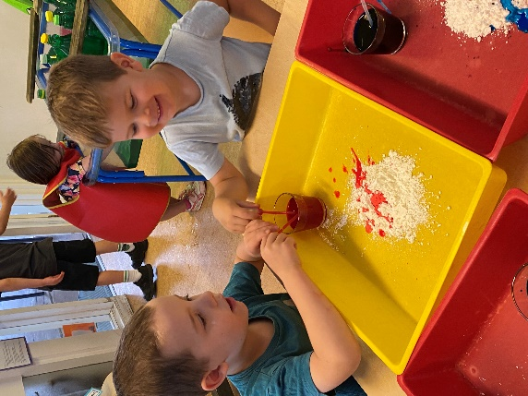
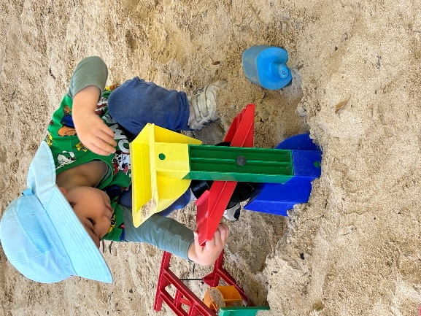
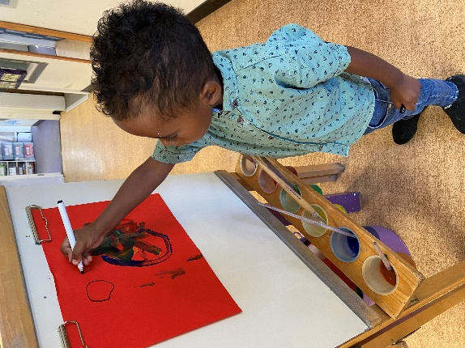

Welcome from Principal
Welcome into our Preschool for 2025 at Hughes Primary School. We are proudly an International Baccalaureate (IB) Candidate School and implement the IB Primary Years programme (PYP). The PYP offers an inquiry-based, transdisciplinary curriculum framework that builds conceptual understanding. It is a student-centred approach to education with the premise that students are agents of their own learning and partners in the learning process. It prioritizes people and relationships to build a strong learning community for the five hundred students here at Hughes PS.
The Southside Introductory English Centre is based within our school, and we welcome many families from different countries, greatly benefiting from a wide multicultural presence. Together we have built and continue to build a community of inclusion, valuing diversity and respect.

Our Mission Statement
We support each child to flourish. Through evidence based and future focused education, we foster inquiring, knowledgeable and caring young people. We demonstrate intercultural understanding and respect and act to create a better and more peaceful world.

Our motto ‘Learning for Life’ captures our commitment to ensuring students have the knowledge, skills and experiences needed to be active and informed citizens.

The teaching teams at Hughes have very high levels of pedagogical knowledge and skill, including expert knowledge of teaching strategies, to improve student learning and wellbeing. Ongoing professional learning of all Hughes staff is an important priority as is the development of a whole school reflective culture focused on improving classroom teaching.

A celebrated feature of our school community is the dedicated and enthusiastic support of our parent community. We highly value connected relationships with parents and extended family, all working together to shape a love for learning. Our school has two main values that underpin our work, our thinking and actions. We embrace the opportunity to actively promote our key values and beliefs.
Our values are:
· Be Kind
· Try Your Best

We look forward to a vibrant and exciting learning journey with your child and your family.

Nina McCabe
Principal

Contact Details
Education Directorate Contact Details
- 6205 5429 for general enquiries
- https://www.education.act.gov.au/

School Contact Details
  - Principal: Nina McCabe (Nominated Supervisor)
  - Preschool Supervisor: Hayley Singh
  - Executive Teacher Kindergarten – Year 3: Kirsty Stewart (Certified Supervisor)
  - Preschool Staff:
    - Susan Jones (Educational Leader, Certified Supervisor)
    - Kate Oldfield and Brooke Suitor (Educators - Assistants)

  - School Phone number: (02) 6142 0730
  - Preschool Unit phone: (02) 6142 0741

Hours of Operation
Owls | Monday - Tuesday | 9.00 am | 3:00 pm
Odd weeks | Wednesday | 9.00 am | 3:00 pm
Butterflies | Thursday - Friday | 9.00 am | 3:00 pm
Even weeks | Wednesday | 9.00 am | 3:00 pm

Term Dates
Term 1 | Monday 3 February – Friday 11 April 2025
Term 2 | Tuesday 29 April – Friday 4 July 2025
Term 3 | Tuesday 22 July – Friday 26 September 2025
Term 4 | Tuesday 14 October – Tuesday 18 December 2025
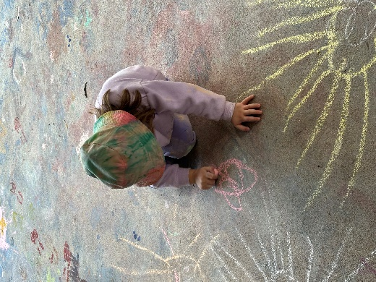
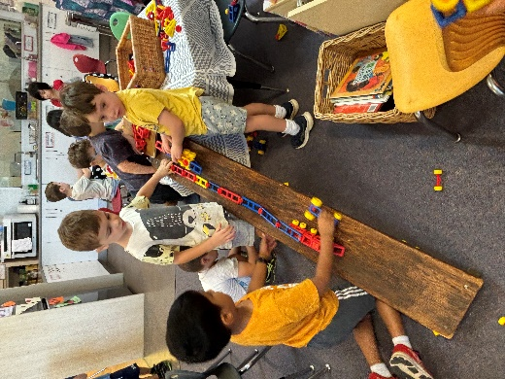
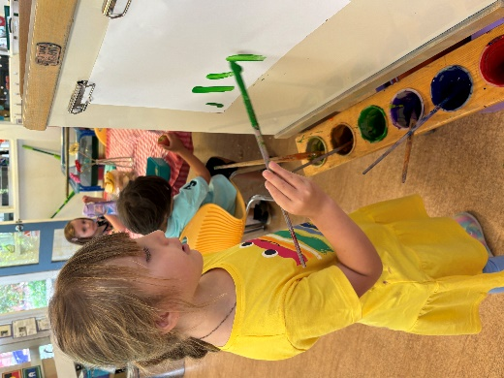

Hughes Preschool Philosophy Statement

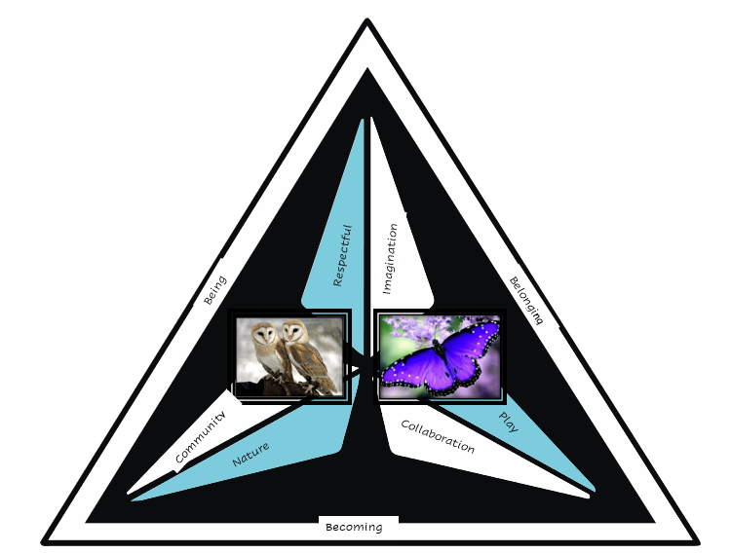


At Hughes Preschool we value children as capable risk takers who are unique and creative. We are committed to holding high expectations of children and recognising that all children have the right to participate in our inclusive learning environment. We foster children to become independent learners who collaborate with each other. Helping them develop a positive attitude to education through providing time to reflect, practice and learn with an understanding that mistakes are part of learning and growing.

We provide a high-quality, extensive, and challenging curriculum based on learning through play using the Early Years Learning Framework. We extend children’s personal interests, encouraging them to reach their true potential in all areas of learning. We inspire them to become explorers, investigators, and discoverers as they are the protagonists in their learning. Combining the security, happiness, comfort and care which children could expect to experience at home with the stimulation, learning and social awareness of a school setting. We view educators as researchers in children’s learning journeys through a pedagogy of listening.

We provide a happy, safe, and stimulating environment where children, parents, carers and visitors feel welcomed and valued as members of the school community. Our learning environment reflects our conviction that aesthetically engaging, carefully planned and thoughtful environments significantly enhance the quality of learning experiences. With deliberate intent, we facilitate experiences and provocations which offer possibilities for children to learn in nature. We embrace respect for diversity in our learning community and acknowledge the traditional owners, past, present and in the future for their invaluable contribution to our school community.

We value a culture of collaboration with families, carers, and the community. Through observing and learning from what children say and do, we endeavour to build secure, respectful, and reciprocal relationships with all members of the community. This is vital for creating a shared dialogue and learning from one another and engaging in ongoing learning and reflective practice for the children and educators.

When we asked all families to offer 3 words that reflected their own and their child’s experiences and thoughts on preschool. This is the Wordle that was created from their responses and our philosophy.

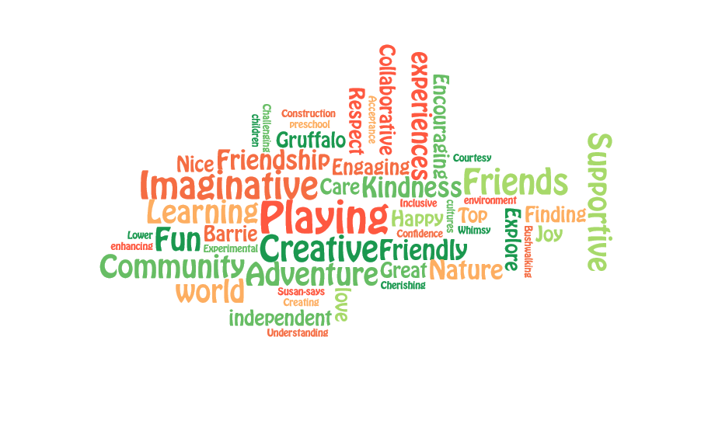

Curriculum
The Early Years Learning Framework has been developed to ensure your child receives quality education programs in their early childhood setting. This is a vital time for them to learn and develop. The Framework’s vision is for all children to experience play-based learning that is engaging and builds success for life. You can access the Early Years Learning Framework in English and other languages by using the QR code below.

It is a guide for early childhood educators who work with children from birth to five years. The Framework is used in partnership with families, children’s first and most influential educators, to develop learning programs responsive to children’s ideas, interests, strengths and abilities, and recognise that children learn through their play.
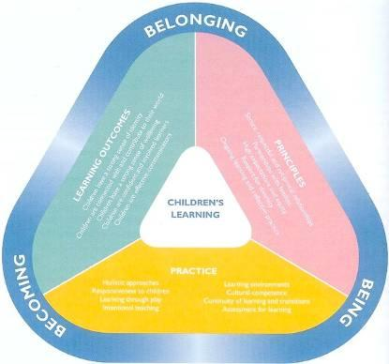


The Early Years Learning Framework describes childhood as a time of belonging, being and becoming.

- Belonging is the basis for living a fulfilling life. Children feel they belong because of the relationships they have with their family, community, culture and place.
- Being is about living here and now. Childhood is a special time in life and children need time to just ‘be’—time to play, try new things and have fun.
- Becoming is about the learning and development that young children experience. Children start to form their sense of identity from an early age, which shapes the type of adult they will become.


To view Education Directorate policies, visit the policy site through the QR code below.

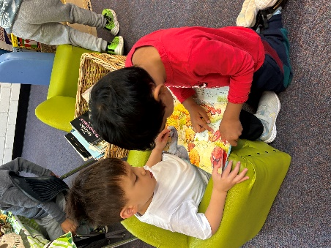
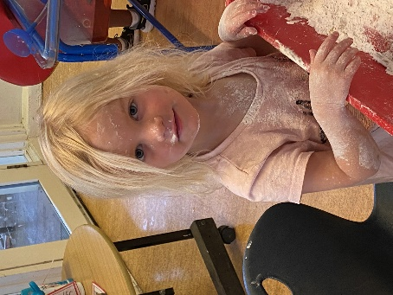

National Quality Framework
Overview
The National Quality Framework aims to raise the quality of education and care across Australian services by introducing a National Quality Standard - this is a standard that all services work to. Other elements include a national assessment and rating process.
The NQF provides families with information on the quality of care to help them make informed choices about which service will best meet their needs.

National Quality Standard
The National Quality Standard is divided into seven Quality Areas:
Hughes Preschool has an overall rating of EXCEEDING.
With 6 out of the 7 Quality Areas being awarded EXCEEDING.
- Educational program and practice
- Children's health and safety
- Physical environment
- Staffing arrangements
- Relationships with children
- Collaborative partnerships with families and communities
- Leadership and service management.

The National Quality Standard aims to promote:
- the safety, health and wellbeing of children
- a focus on achieving outcomes for children through high-quality educational programs
- families' understanding of what distinguishes a quality service.

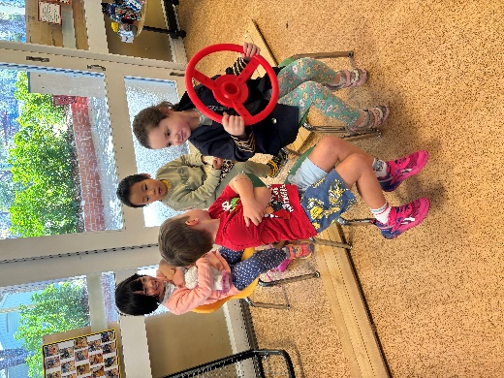
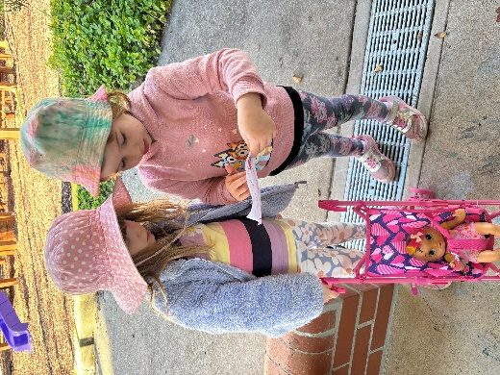
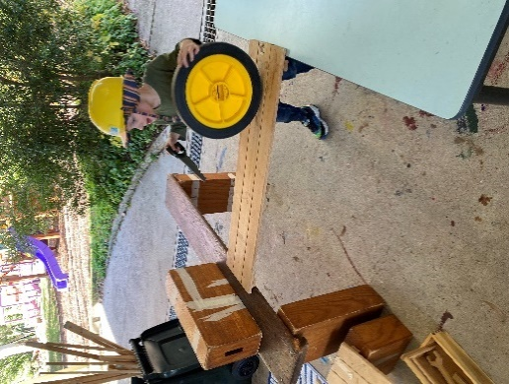

A – Z of Information

Arriving and Departing - Delivery and Collection of Children
Regular attendance is important as this allows the children to settle into routines and establish themselves as part of the group. If your child is absent a note is required, and a phone call or email appreciated. In accordance with the National Quality Standard, collection of children must be by a parent or authorised nominee. Children are to be dropped off at Preschool at 9 am to the preschool team (not the school grounds), on arrival all the children must wash their hands. Every child must be picked up promptly at 3 pm. If a child arrives after 9.30 am or collected before 2.30 pm, they need to be signed out in the attendance record book. It is important that parents are on time to collect children as staff are involved in preparation, program planning and administrative tasks before and after sessions and are not free to supervise the children.
Extreme caution should be undertaken when driving in the preschool car park and surrounds, observing a 10 kph speed limit. Please keep driveways clear at all times. Parents are requested to hold their child’s hand at all times in the shared zone. Please take care when entering and exiting the preschool to secure the gate and not allow children other than your own to leave. Children can store their bike or scooter at preschool. However, they must not be used within the preschool grounds.

Before and After School Care
Woden Community Services will be offering before and after school care on the main site. Please contact enrolments@wcs.org.au or call 6147 3318 for more information.

Beginning of the Year Arrangements
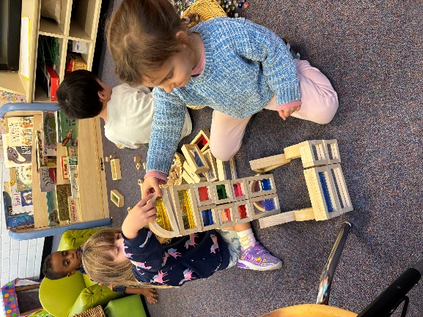
To support the children as they transition into a new learning environment and become a member of the Owls or Butterflies, we invite you and your child to join the current preschool team for two orientation session. The children will play, explore and begin to form some friendships. They will have the experience of story and group time, morning tea and challenging themselves outside. Details and dates for these visits were mailed to you with your child’s welcome letter. On your child’s first day we will begin the day with a graduated start. This is essentially small groups of 5 or 6 arriving at staggered intervals of time. This allows the preschool team to welcome the children, help them with the new routine and settle to an area of interest as they say goodbye to families before welcoming the next small group. Feedback from previous families has been this has assisted the children and is a positive experience for parents and carers too. Further information on the gradual start, including nominating a time, will be sent prior to the 2025 school year.

Belongings
It is important to label every item of your child’s belongings to avoid misplacing them. Hats, jackets, lunch boxes, drink bottles, spare clothes, library bag, school bag and anything that your child might bring to preschool should be clearly marked with their name. Children are asked NOT to bring toys or items of value to preschool.

Birthdays
Birthdays are celebrated at preschool. If you would like to supply small cakes (e.g. small cupcakes, muffins) that are easy to manage and are enjoyed by the children please let the staff know. Please keep in mind that we are a NUT AWARE school, some children have allergies and small cakes/muffins must be nut free. If your child is unable to eat cake, an alternative treat may be brought. Prepacked food is preferred.

Celebrations
We welcome celebrations that are significant to your child and family and we would like to acknowledge these in ways that are appropriate and significant.
We would like these and other celebrations at preschool to be meaningful and reflect the diversity of cultures, so if there is anything in particular that you and your family celebrate in the year, or if there are celebrations that you’d prefer your child was not involved in, please let us know so that we can meet the needs of your child and your family.

Changes to Details
Please keep staff and the school informed of any changes to address, home/work phone numbers, childcare arrangements, medical information and emergency contact phone numbers. However, please keep telephone calls to the preschool during session times for urgent matters only as it is disruptive to the program when staff leave the children to answer the telephone.

Child Protection Practices
All employees in schools are mandated to report any case of suspected child abuse or neglect. Failure to notify suspected physical and /or sexual abuse of children is a criminal offence.
Staff will deliver lessons to children in protective behaviour and safe behaviours. Staff will also deliver lessons to enhance social and emotional skills.

Clothing
Please dress your child in sensible clothes to allow free movement and participation in a wide range of play experiences, some of which can be messy, so we ask not to send your child in their ‘best’ clothes. Shoes should do up firmly around the feet. Thongs, Crocs or slip-on shoes are not suitable. Please clearly label all clothing, including shoes, with your child’s name. A hat is essential, and a warm coat is necessary in winter. We also ask for every child to supply a pair of gumboots to stay at school.
Please also provide a change of clothing (labelled) for your child in their bag every day. Accidents do occur with paint, water and toileting. Clothing should be easily managed by your child so that he/she can be independent, especially when going to the bathroom.

Concerns, Complaints or Commendations
If you have a concern about your child’s education, please have a conversation with the Preschool Teacher. You are also welcome to make contact with the P-2 Executive Teachers.
Should the need arise the ACT Education and Training Directorate has a policy for complaints resolution. This policy can be accessed at http://www.det.act.gov.au/publications_and_policies/policy_a-z
You can also contact the Children’s Education & Care Assurance (CECA)

Communication avenues with staff
Our school recognise the importance of a positive parent/staff relationship. We encourage:
- sharing knowledge to enhance the growth and development of your child;
- developing positive relationships with families that are based on mutual trust and open communication; and
- developing a sense of belonging to the preschool for the children, parents and staff.
Important notices are placed on the weekly noticeboard, which is on display at the preschool, and will be sent through to families by email. The weekly noticeboard provides parents with a snapshot of what the children have been busy exploring and investigating at preschool.
Hughes Primary School newsletters are produced alternate Fridays with information about what is happening in the school. Newsletters are emailed home to families and are available on the school website. You can also access events happening on the school Facebook page and the calendar on the school website.

Parent and Carer ‘getting to know you and your child’ meetings are generally held before the children commence Preschool. It is a time when information can be shared between parents and the preschool to assist with the transition for the children into the preschool environment.

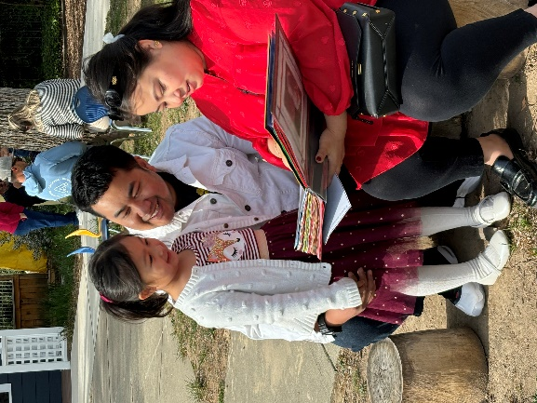
Learning Journeys are held each term, this is an opportunity for you to join with your child and enjoy some of the wonderful and fun learning experiences they have been engaged in.

Teachers appreciate the opportunity to talk with parents and carers both informally and in formal situations. This ensures valuable insights and understandings about a child’s individual developmental journey can be acknowledged. If you have any questions or concerns, please do not hesitate to ask for an appointment to meet with the teacher.

Contribution to decision making
Families are welcome to contribute to the decision-making procedures of the school through the School Board or the P&C.
Board
Each government school in the ACT is administered by a school board whose membership comprises the school principal, two elected staff members, three elected members of the parent body and a nominee of the Department of Education. Elected members normally serve for a two-year period.
The Board is the policy-making body of the school. Its major functions are to:
- determine the educational policies to be implemented at the school.
- assess, from time to time, the needs of the school in relation to the provision of buildings and facilities, equipment, funds and teachers and other staff, and make recommendations to the Chief Executive (of the Department of Education) with respect to the meeting of those needs;
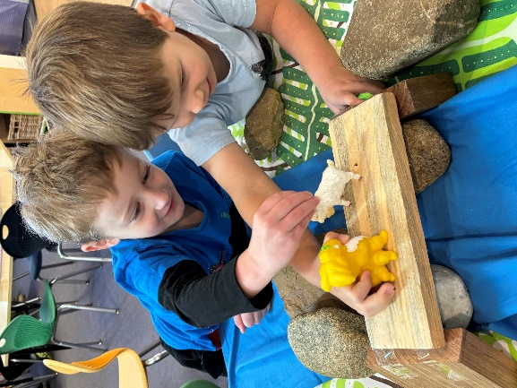
- determine the purposes for which funds made available for the school are to be expended;
- make recommendations to the Chief Executive in respect of the use of the buildings, facilities and equipment of the school for purposes other than school purposes;
- develop relationships between the school and the community and between the school and community organisations; and
- make recommendations to the Chief Executive on matters relating to the school
Responsibility for the implementation of policies established by the Board rests with the principal and staff.

Parents and Citizens Association
The P&C plays an important role within the school. Meetings are advertised in the newsletter and on the school Facebook page. All parents are encouraged to attend the meetings. As well as its more official activities, the P&C provides an informal meeting ground for parents and teachers and serves a fundraising function for the school. Each year we hope to form a preschool subcommittee, which is a group of parents and carers who have children in the preschool. This group will support the staff with special events, such as the annual Art Show and welcome picnic.

As a preschool team we also acknowledge and recognise that as parents and carers you are the children’s first and often most influential educators. To enhance our knowledge of your child we would be thrilled for you to contribute in a range of ways, through offering your skills, insights, experiences, knowledge or simply staying and playing every now and again. The first year of school is a partnership and we wish for you to be as engaged in your child’s preschool experience as possible.

Pockets
Each child has a labelled pocket that hangs outside on the wall. Please check it every day as this is where notes and information will be distributed. Frequently there will also be paintings and creations that the children want to take home to share with you.

Dogs
Parents may not be aware of the provisions of the Dog Control Act 1975 which states in section 23 “a person shall not take a dog into the grounds of a school at a time when pupils are on those grounds”. A dog with a couple of children can be lots of fun, but a dog with a lot of children often results in dog and children becoming over excited and behaving erratically. In the interest of safety, we seek your co-operation ensuring that this regulation is observed.

Under Department of Urban Services policies, dogs are not permitted on school grounds. Section 42 of the Act defines places where dogs are prohibited. These include the grounds of a childcare centre, preschool, primary school, high school or secondary college during school hours or when school sport including training is being conducted unless the keeper of the dog resides in the grounds or a dog is taken into the grounds with the approval of the principal.

Drinks
You will need to provide water only in a named drink bottle for every session. Children will have independent access to this all day. Bottles are placed on the table on arrival at preschool and taken home daily for washing.

Emergency Management Procedures
The school has a policy on emergency evacuations and lock downs, and we are required to practise emergency management procedures. All staff, children and visitors on site must participate.

Excursions/Incursions
Excursions and Incursions are an integral element of the educational program at Hughes Preschool. They allow the children the opportunity of first-hand experiences and the introduction of some new and interesting information and skills. On enrolment, parents are asked to give permission for their child to go on local area excursions, e.g. walk to the shops. As part of our investigations and explorations of the local community and the natural environment, we will be taking the children on bush walks and picnics. Prior preschool groups have delighted in walking and exploring, sharing their knowledge and interests and exploring the surrounds of Red Hill and the Federal Golf club. We aim to continue this in 2025. Some of our excursions are further afield and if the children use any form of transport, parents will be advised in advance and asked to give written permission for the child to attend. The adult/child ratio is 1:4 on major excursions and we appreciate the help of adult volunteers. Volunteers will need to fill in a volunteer nomination form and other relevant paperwork.

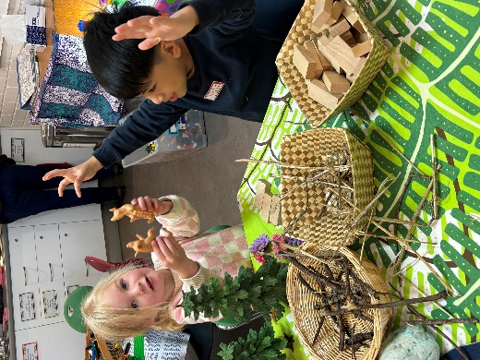
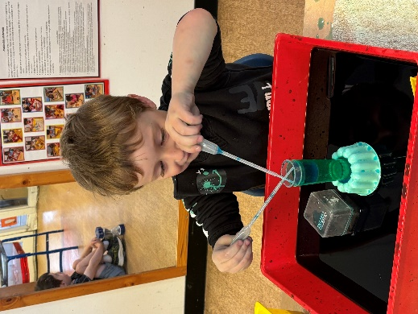
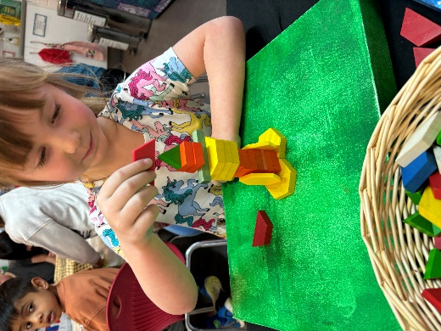
Food
During the preschool day your child will have the opportunity to eat twice, and we ask that each child has a healthy morning tea and then a larger healthy lunch. On arrival in the morning your child’s morning tea should be placed in the special baskets and their lunch remains in their bag. This means they will need 2 food containers, which should be clearly labelled. It is also a good idea to take your child with you when buying lunch/snack boxes to check if they can open them. Let them ‘have a go’ in the shop before you buy something that is impossible for them to undo.
We will focus on developing lifelong healthy eating habits and discourage foods that are high in sugar, fat or salt.

All children will need their own drink bottle with water only. Please note: Hughes Primary School is a nut aware school due to the inclusion of students with life threatening anaphylactic allergic conditions. We ask parents to assist in minimising the risk of a life-threatening anaphylactic shock for students with this condition by not sending foods containing nuts, discouraging food sharing and labelling foods for special events. Further information on this condition can be found at http://www.allergy.org.au/

Food Safety Tips for Homemade Lunches & Snacks
Healthy lunches and snacks are important for children and help with their concentration and learning. School lunches can be particularly susceptible to food poisoning, especially in the summer heat. Parents and carers are reminded of a few simple food safety rules to prepare safe and healthy school lunches and avoid the growth and contamination of food poisoning bacteria.
- Before handling food, wash hands with soap and warm running water and dry thoroughly. Lunch boxes and eating utensils should also be washed thoroughly before reuse. Children should also be encouraged to always wash their hands before eating.
- Foods that are prepared the night before, such as sandwiches, should be frozen overnight and then taken out for each day’s school lunch. Suitable foods to freeze are: bread, cooked meat, cheese, baked beans or vegemite.
- Because food is normally stored in a child’s lunch box for several hours, the lunch box needs to be kept cool. This can be done by:
  - Choosing an insulated lunch box or one with a freezer pack, or include a wrapped frozen water bottle to keep the lunch box cool.
  - Perishable foods such as dairy products, eggs and sliced meats should be kept cool, and eaten within about four hours of preparation. Don’t pack these foods if just cooked; first cool in the refrigerator overnight.
  - If including leftover meals such as meats, pasta and rice dishes, ensure you pack a frozen ice block into the lunch box. We are unable to reheat food for the children.

To view information regarding healthy food and children visit:
• Healthy Eating At Various Lifestages page on the Australian Government Department of Health and Aging website
• Healthy Kids NSW

Gates
For the safety of all children, please ensure the gate is securely closed when entering and leaving the preschool grounds. Children are not to climb on the gates. Please check you only have your child with you as you leave.

Hats
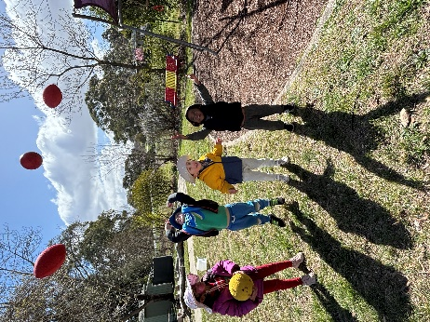
Sun hats must be provided at preschool every day throughout the year. Each child will have their own special hat peg and we would prefer if they could always leave a hat at school as 4 and 5 years olds find it very difficult to follow the rule; NO HAT – PLAY IN SHADED AREAS ONLY. As part of the ACT Cancer Councils recommendations during June and July the children can wear warmer winter beanies. Please ensure that cords on sunhats are detachable in compliance with Directorate regulations. Please remember to label with your child’s hat.
View Education and Training Directorate Sun Protection policies

Immunisation
When you enrol your child into an ACT primary school or preschool you are required to provide the school two copies of your child’s immunisation record or a statement or declaration of their immunisation history. This information allows action to be taken to minimise disease spread if a vaccine preventable disease such as measles or whooping cough occurs at the school.
Comprehensive information about the public health requirements for immunisation, infectious disease notification and exclusion of unimmunised children is contained on the ACT Health website at https://www.health.act.gov.au/services-and-programs/immunisation/babies-and-children/what-vaccines-does-my-child-need-and-when. You can also contact the ACT Health, Health Protection Service, Immunisation Information Line on 02 5124 9800 if you have any questions or require additional information.

Information on Hygiene Procedures
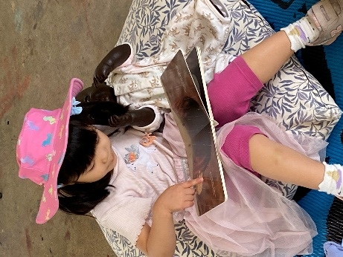
Staff, children and volunteers must adhere to the hand washing procedures.
All children are encouraged to wash their hands:
- On arrival
- Before and after eating or touching food
- After toileting
- After blowing their nose and wiping tears and dribbles
All scratches and cuts must be covered.

Learning Journals
Every child will have a Learning Journal. Over the year this will build up to become a comprehensive and yet individual record and reflection of your child, their interests, creations, discoveries and explorations within the preschool. We really encourage you to regularly find time to share the special folder with your child. There will also be regular occasions when you will be able to look at the Learning Journals, such as the Learning Journeys and at preschool social occasions. However, if you wish to, please take the folder home. Throughout the year we would really love for you to add your comments, assisting in the creation of a wonderful document for your child to look at when they are 21.

Library Bag
Please provide a separate named cloth bag to carry and store borrowed preschool books safely. We request that all books be cared for and replaced if lost or damaged. This bag is not for carrying craft items. The preschool has established a library to:
- encourage families to spend time together reading
- underpin literacy learning
- foster enjoyment of reading
- develop language expression and understanding and
- encourage a responsible attitude towards the care of books at preschool and at home.

Medical Condition Management
- Immunisation: The ACT Department of Health advises that all children attending school in the ACT should be immunised against diphtheria, tetanus, whooping cough, polio, measles, mumps, rubella and HIB (Haemophilus influenza type b). We would ask that you check your child's present immunisation status to see whether it is complete for their age. ACT Public Health regulations require schools to request proof of up-to-date immunisation when enrolling. Failure to provide this may result in your child being excluded from school should an outbreak of an infectious disease occur. A copy of exclusion periods for students with infectious diseases is available. Parents are asked to adhere closely to these requirements unless medical advice to the contrary is provided in writing.
- Exclusion periods for infectious diseases such as mumps, German measles, measles and chicken pox are provided at the end of this handbook. If a child is to take a prescription medicine while at school, written directions and medicine must be left with staff. Information on a child’s health status e.g. epilepsy, diabetes, should be given on enrolment or on diagnosis. If the health problem is serious, please provide an up-to-date photograph of the child so it can be placed on our Medical Alert board.
- Head lice are extremely contagious but easily eradicated. Children with either eggs or live lice will be excluded from school until after treatment Please report any cases of head lice to the preschool staff.
- Medical and Accidents: It is important that sick children are kept at home for their own comfort as well as the health of other children and staff. If a child becomes ill or is injured at school appropriate First Aid will be given. Parents will be notified and asked to take their child home if necessary. If emergency treatment is required parents will be notified immediately and the child will be transferred by ambulance to hospital. In such cases ambulance services and treatment are free. All students who have an ongoing condition (e.g. asthma, diabetes, epilepsy) must have a treatment plan completed by parents and their GP and lodged at the school. Plan proformas are available from the Front Office or from a staff member in the preschool.
- Nuts: Hughes Preschool is a ‘Nut Aware’ school. To protect children who may have serious allergies we would ask you to NOT provide any nuts or food containing nuts.

Parent Support
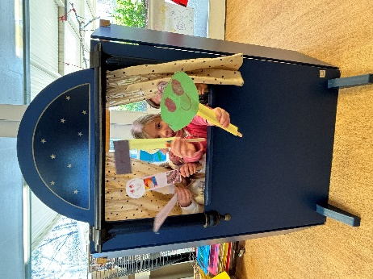
Parentlink: http://www.parentlink.act.gov.au is a website which parents can use to access:
- parent guides, including electronic order forms
- a directory of local parenting services
- upcoming community events and parenting courses
- further readings in relation to the parent guides and
- links to other useful websites.

Parking
Parents are urged to exercise extreme caution in the car parks, especially after school when the car parks are very busy. Please don’t block the entrance and exits and be aware of other drivers. Parents are encouraged to park on Brand Street and walk down the path.

Parental Engagement
We value parents and carers involvement in preschool and recognise and acknowledge that you are the children’s first educators. We regard parents and carer’s contribution to the preschool and the children’s learning experiences as invaluable extensions of the children’s learning and wonderful opportunities for all members of the preschool.
Families are encouraged to participate in social activities this assists in enabling parents and carers to meet each other, build networks and form a sense of belonging to the school community. We encourage parents and carers to share their special skills, interests and diverse family cultures with the preschool community.
Families can help in many ways here are just a few examples:
- sharing knowledge and expertise of job skills, interests, passions, craft, cooking, music, storytelling, etc.
- interacting with the daily program
- assisting with laundry
- working bees in the garden etc.
- joining Hughes P&C

Participation, Equity and Access
At Hughes Preschool we aim to provide equal opportunities for all children to promote optimal development. The program values the child’s prior learning and experiences and aims to assist all children to participate in a wide range of learning experiences and to develop their confidence and self-esteem.

Participation of Volunteers
Volunteers have a special place in schools and assist in many ways. This may include interaction with individuals and small groups of students in a range of different activities. Volunteers may need to apply for a Working with Vulnerable People card. If you volunteer for no more than three days in any 28-day period, and up to a maximum of seven days in any twelve-month period, you are not required to register for a Working with Vulnerable People card. Please see the school front office for further information.
To assist schools in providing a safe environment and a positive educational climate, volunteers will need to fill in a Volunteer Nomination Form and other relevant documents. These are available through the front office. Volunteers are asked to comply with the Code of Conduct for Volunteers. This code of conduct has been formulated to clarify the type of conduct that is expected of volunteers when participating in programs and activities in ACT Government schools.
- Observe similar standards of behaviour and ethical conduct to that required of staff. For example, you are expected to act within the law, be honest and fair, respect other people (including students), and work to the best standard of your ability.
- Appreciate that teachers have a special duty of care for students that cannot be delegated or transferred to others. Appreciate also that the principal is the spokesperson for the school.
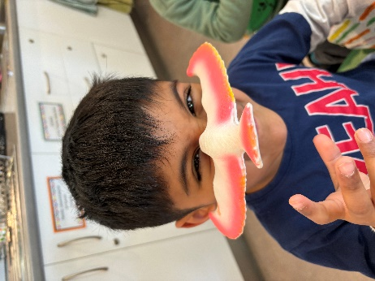
- Appreciate that students have rights and aspirations. Treat students with dignity and respect.
- Observe confidentiality in respect of all information gained through your participation as a volunteer. All information held by schools should be handled with care. Some information is especially sensitive. Sensitive and/or personal information requires additional caution in the way it is treated. For example, volunteers should not discuss nor disclose personal information about students, staff or students’ parents/carers to others.
- Accept and follow directions from the principal/supervisor and seek guidance through clarification where you may be uncertain of tasks or requirements. You may need to familiarise yourself with the department’s policies and guidelines on particular issues.
- Observe safe work practices which avoid unnecessary risks, apply reasonable instructions given by supervisors and report to the supervising staff and school administration any hazard or hazardous practice in the workplace.
- Report any problems as they arise to your supervisor including incidents, injury or property damage.
- Avoid waste or extravagance and make proper use of the resources of the school/department.

Photography
Photographs are taken regularly at preschool of the children in their play and learning experiences. They are used as an integral part of the preschool program and will be compiled into a short slideshow for your child as part of their Learning Journals. The school also has a Facebook page that highlights the wonderful experiences within the school. We never put children’s names on the website, and photographs of the children are from above or behind. Please read and sign the permission form provided in your information pack. If you have any questions, please speak to a staff member.

Physical Activities
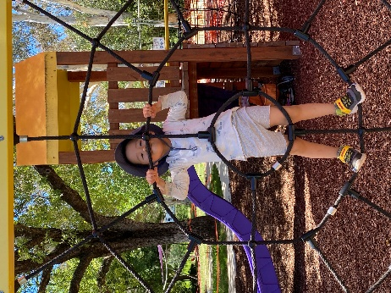
Physical activity is very important for children, so educators provide opportunities for structured and unstructured physical activity.
During the preschool sessions, your child will be involved with many hands-on experiences in both the outside learning environment and the inside area. These activities can, at times, be very messy. Please ensure your child is dressed appropriately so that they feel confident to participate in all the challenges provided throughout the session. A warm coat and hat are required in winter. The children will be challenging themselves on the climbing equipment so sensible footwear is essential and long dresses and skirts can be dangerous. Please label all your child’s clothing and pack a spare set-in case of extremely messy play or accidents.

Policies
Preschools are part of the ACT Education Directorate. Some of the major policies and frameworks under which preschools operate are:
- Safe and Supportive Schools Policy (2016)
- Sun Protection Policy (2015)
- Smoke-Free Workplace Policy (2008)
- Excursions – Policy and Mandatory Procedures (2016)
- First Aid Policy (2017)
- Working with Children and Young People – Volunteers and Visitors Policy (2016)
- Complaints Policy (2016)
- Child Protection and Reporting Child Abuse and Neglect Policy (2016)
- ACT Department of Education and Training Strategic Plan
All Directorate policies may be viewed in entirety on the ACT Directorate Policy website through the QR code on page 9. Further information on policies and procedures can be found through the QR code below.

National Law and Regulations Link

Rest and Relaxation
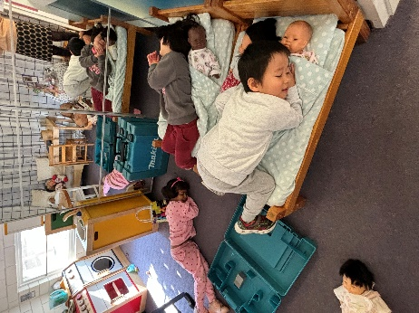
We recognise that every child is unique and will need to rest at different times of the day. To accommodate this, the learning environment have been organised so that the children can independently choose to have some quiet time, reading books, drawing, or listening to music. All children have time for quiet, restful reading after the morning’s investigations. The outside learning environment supports the belief that children should be able to choose if they need time to relax and rest. A quiet table and mat areas in the cubby house have been arranged to facilitate/support any child’s need for a quiet space to relax and rest if they wish to. The daily routine has also been designed so the end of the day is a quiet story and reflection time.

Stay and Play and Laundry
Parental involvement contributes significantly to the life of the preschool. Your help is greatly appreciated by the staff and children. Stay and Play involves spending time at preschool being part of the program in various ways. It is an excellent opportunity to learn about your child’s day and understand the play-based program. Stay and Play sign-on sheets are available at the preschool and we would encourage all of you to add your name for a day/time that suits you. Once a week for each group, there is a small bag of laundry (tea towels and tablecloths) that requires washing. We encourage all families to volunteer for this task as the help is much appreciated.

Student Welfare and Management
At Hughes Primary School we value that everyone is an individual and that we all have special qualities that make us who we are. All students are treated with respect and are expected to treat staff in the same manner. We provide a supportive, welcoming and culturally inclusive educational environment where students feel safe and happy. The school has a Safe and Supportive Schools policy that outlines the steps for addressing student welfare and management issues.

Sun Protection
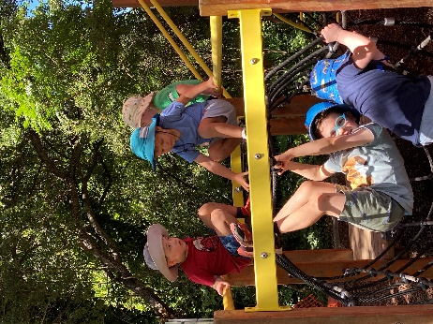
To ensure that all children are protected for the sun we ask that each family provides a wide brimmed hat for the child to wear during outside time. We ask that you apply sunblock to your child at home each morning, and that you supply a roll-on sunscreen for your child to reapply during the day. Please try to send your children in clothes that provide some protection from the sun, particularly on the shoulders and back.

Sustainability
Throughout the year the children will be introduced to the importance of respecting and valuing the natural environment and learn the important skills of Reduce, Reuse and Recycle. We ensure that any items that can be recycled or reused are. If you can, please bring in your cardboard boxes and any interesting items to share that can be used as part of the children’s creative explorations. The children will be encouraged to think about being water wise as they use the water from the water tray in the sand pit, the bush kitchen and to water the gardens. They will be introduced to two bins in the room, one for recycling and one for rubbish that is not able to be recycled. We would love to introduce the children to keeping food scraps for chickens, if you have chickens and would like the scraps left from children’s lunches, please let us know.

Transitions
While enrolled at preschool, your child is a member of the Hughes Primary School community and will participate in whole school events when appropriate.
Please note, that if you are out of the Hughes Primary catchment area and would like your child to attend Kindergarten at Hughes the following year, you will need to re-enrol through the ACT Education Directorate’s website. Out of area enrolments are dependent on capacity limits in Kindergarten. If your child will not be attending Hughes Primary School the year following preschool, you will need to inform the front office staff at the primary school and your child’s class teacher. If you require documentation for your new school, please make your request at least two weeks prior to departure. As with all transitions the staff will ensure that the move from preschool to kindergarten is successful. To do this we have implemented a transition program for our preschool children. This involves:
- Carefully planned transition experiences
- Sharing of information between families and school
- Planned orientation experiences
- Informal and formal inclusion in whole school activities
- Pedagogical practices that support identity building
For more information about this topic please follow the link to this website for some helpful hints: Starting school - a guide for parents

Toys
Please do not bring toys to preschool as it causes distress for your child if it goes missing or gets damaged.
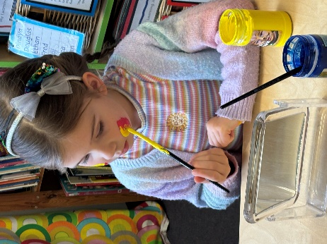
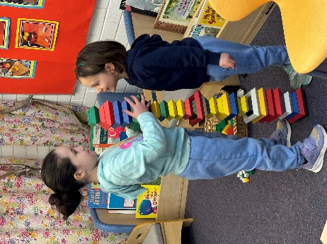
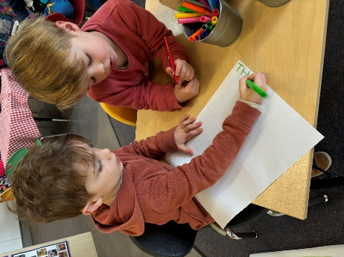

Diseases - Outbreak Procedures and Exclusion Periods

Personal hygiene measures such as hand washing, covering the mouth and nose when coughing or sneezing, covering weeping sores, not sharing food or drinks and not attending school when ill or suffering from diarrhoea are important means of limiting the transmission of a number of common infectious conditions. If your child is showing any symptoms of being sick, please keep them at home. You will be contacted to collect your child if they show signs of illness at school.

The ACT Public Health Regulations 2019 require children with the following conditions, and children who have been in contact with the following conditions, to be excluded from school, preschool, childcare or family day care for the periods specified.

Condition | Exclusion of person with condition | Exclusion of persons in contact with condition
Amoebiasis (entamoeba histolytica) | Exclude until diarrhoea ceases | Not excluded
*Campylobacteriosis | Exclude until diarrhoea ceases | Not excluded
Chicken pox (varicella and herpes zoster) | Exclude until the last blister has scabbed over.  The child should not continue to be excluded by reason only of some remaining scabs. | Not excluded  Any child with an immune deficiency (e.g. with leukaemia, or as a result of receiving chemotherapy) should be excluded for their own protection and seek urgent medical advice and varicella-zoster immunoglobulin (ZIG), if necessary.
Conjunctivitis (acute infectious) | Exclude until discharge from eyes ceases. | Not excluded
*Cryptosporidiosis | Exclude until diarrhoea ceases | Not excluded
Diarrhoea | Exclude until diarrhoea ceases | Not excluded
*#Diphtheria | Exclude until—  (a) at least 2 negative throat swabs have been taken (the first not less than 24 hours after cessation of antibiotic treatment and the second not less than 48 hours later), and  (b) A certificate is provided by a medical practitioner recommending that the exclusion should cease. | Exclude family and household contacts until approval to return has been given by the Chief Health Officer.
Giardiasis | Exclude until diarrhoea ceases | Not excluded
*#Haemophilius influenza type b (Hib) | Exclude until a certificate is provided by a medical practitioner recommending that the exclusion should cease. | Not excluded
Hand, Foot and Mouth disease | Exclude if—  (a) child is unwell, or  (b) child is drooling, and not all blisters have dried, or an exposed weeping blister is not covered with a dressing. | Not excluded
*Hepatitis A | Exclude for at least 7 days after the onset of jaundice and a certificate is provided by a medical practitioner recommending that the exclusion should cease. | Not excluded
Herpes (cold sores) | Exclude young children unable to comply with good hygiene practices while the lesion is weeping. Lesion to be covered by a dressing in all cases, if possible. | Not excluded
Impetigo (school sores) | Exclude until appropriate treatment has commenced and sores on exposed surfaces are covered with a watertight dressing. | Not excluded
Influenza and influenza-like illnesses | Exclude until well | Not excluded
*Leprosy | Exclude until approval to return has been given by the Chief Health Officer. | Not excluded
#Measles | Exclude for at least 4 days after the rash appears. | (a) Immunised contacts not excluded.  (b) Exclude non-immunised contacts until 14 days after the first day of appearance of the rash in the index case.  (b) Non-immunised contacts immunised with measles vaccine within 72 hours after their first contact with the index case are not excluded after being immunised.  (d) Non-immunised contacts who are given normal human immunoglobulin (NHIG) within 7 days after their first contact with the index case are not excluded after being given NHIG.
Meningitis (bacterial) | Exclude until well | Not excluded
*Meningococcal infection | Exclude until adequate carrier eradication therapy has commenced. | (a) Not excluded if receiving rifampicin or other antibiotic treatment recommended by the Chief Health Officer.  (b) Otherwise, excluded until 10 days after last contact with the index case.
*#Mumps | Exclude for 9 days after onset of symptoms, or until parotid swelling goes down (whichever is sooner). | Not excluded
*#Poliomyelitis | Exclude for at least 14 days after onset of symptoms and until a certificate is provided by a medical practitioner recommending that the exclusion should cease. | Not excluded
Ringworm, scabies, pediculosis (lice), trachoma | Exclude until effective treatment has commenced. | Not excluded
Rotavirus | Exclude until diarrhoea ceases | Not excluded
*#Rubella (German measles) | Exclude for 4 days after the appearance of the rash. | Not excluded  Female staff of child-bearing age should ensure that their immune status against rubella is adequate.
*Salmonellosis | Exclude until diarrhoea ceases | Not excluded
*Shigellosis | Exclude until diarrhoea ceases | Not excluded
Streptococcal infection (including scarlet fever) | Exclude until the person has recovered or has received antibiotic treatment for at least 24 hours. | Not excluded
*Tuberculosis | Exclude until approval to return has been given by the Chief Health Officer. | Not excluded
*Typhoid and paratyphoid fever | Exclude until a certificate is provided by a medical practitioner recommending that the exclusion should cease. | (a) Not excluded unless the Chief Health Officer notifies the person in charge of the school. (a) If the Chief Health Officer gives notice, exclusion is  subject to the conditions in the notice.
*#Whooping cough (pertussis) | Exclude for 21 days from start of cough, or for at least 5 days after starting a course of antibiotics recommended by the Chief Health Officer. | Exclude non-immunised household, home based childcare and close child care contacts under 7 years old for 14 days after the last exposure to infection, or until 5 days after starting a course of antibiotics recommended by the Chief Health Officer (whichever is sooner).
Worms (intestinal) | Exclude until diarrhoea ceases | Not excluded
A parent/carer of a child with a listed exclusion condition or a child who has been in contact with a listed exclusion condition must notify the school principal or principal carer as soon as possible.
*These conditions must be notified by medical practitioners to the Chief Health Officer.
