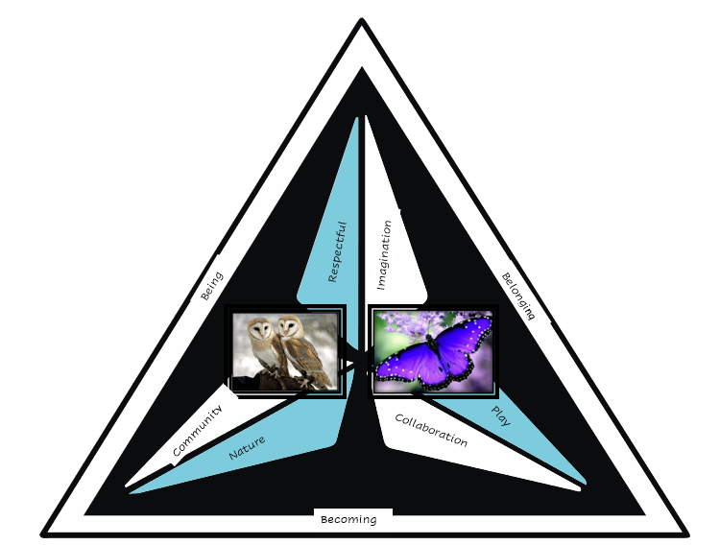

At Hughes Preschool we value children as capable risk takers who are unique and creative. We are committed to holding high expectations of children and recognising that all children have the right to participate in our inclusive learning environment. We foster children to become independent learners who collaborate with each other. Helping them develop a positive attitude to education through providing time to reflect, practice and learn with an understanding that mistakes are part of learning and growing.

We provide a high-quality, extensive, and challenging curriculum based on learning through play using the Early Years Learning Framework. We extend children’s personal interests, encouraging them to reach their true potential in all areas of learning. We inspire them to become explorers, investigators, and discoverers as they are the protagonists in their learning. Combining the security, happiness, comfort and care which children could expect to experience at home with the stimulation, learning and social awareness of a school setting. We view educators as researchers in children’s learning journeys through a pedagogy of listening.

We provide a high-quality, extensive, and challenging curriculum based on learning through play using the Early Years Learning Framework. We extend children’s personal interests, encouraging them to reach their true potential in all areas of learning. We inspire them to become explorers, investigators, and discoverers as they are the protagonists in their learning. Combining the security, happiness, comfort and care which children could expect to experience at home with the stimulation, learning and social awareness of a school setting. We view educators as researchers in children’s learning journeys through a pedagogy of listening.

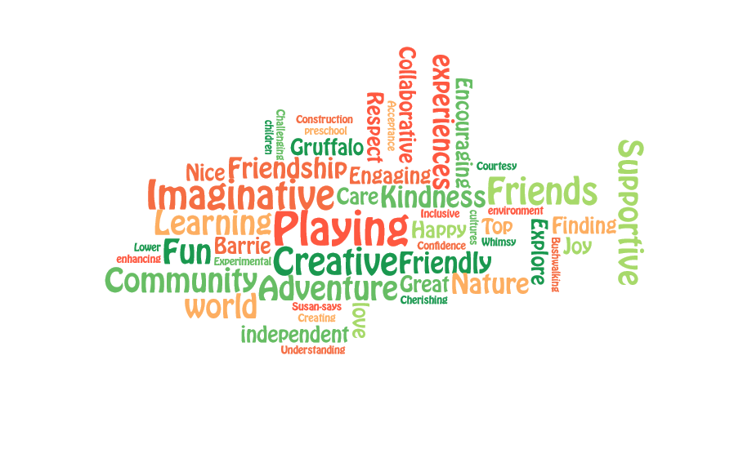
We provide a happy, safe, and stimulating environment where children, parents, carers and visitors feel welcomed and valued as members of the school community. Our learning environment reflects our conviction that aesthetically engaging, carefully planned and thoughtful environments significantly enhance the quality of learning experiences. With deliberate intent, we facilitate experiences and provocations which offer possibilities for children to learn in nature. We embrace respect for diversity in our learning community and acknowledge the traditional owners, past, present and in the future for their invaluable contribution to our school community.

We value a culture of collaboration with families, carers, and the community. Through observing and learning from what children say and do, we endeavour to build secure, respectful, and reciprocal relationships with all members of the community. This is vital for creating a shared dialogue and learning from one another and engaging in ongoing learning and reflective practice for the children and educators.

